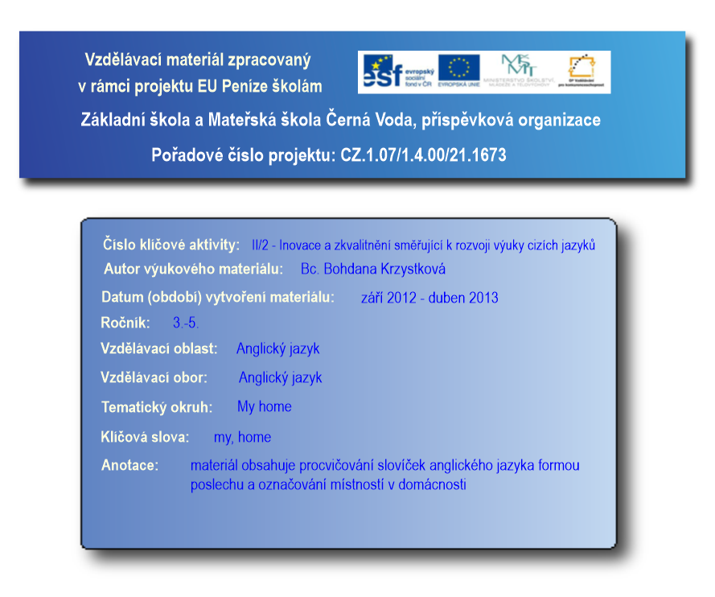
Anotace: Plánek bytu učitel promítne na popisovatelnou tabuli. Čte žákům věty, kde se které místnosti nacházejí, a žáci je podle poslechu určují a na tabuli označují.
Výstup: Procvičení poslechu a orientace v plánku.
Druh materiálu: Multimédia
Zdroje: archiv autora

1/ There is a big room next to the hall on the right. There are two windows in this room. It is the living room.
2/ There is a small room next to the hall on the right. It is the bathroom.
3/ There is the Mary’s bedroom opposite the bathroom.
4/ There is the Rob’s bedroom next to the Mary’s one on the left.
5/ There are two rooms opposite the children’s rooms. One room has got two windows. It is the parent’s bedroom.
6/ Where is the kitchen?

Řešení:
6/ The kitchen is between the parent’s room and the living room.

